ASKING FOR ADDRESS AND GIVING DIRECTIONS

ASKING FOR ADDRESS = ADRES SORMAK
Excuse me! Is there a school around here?
(Pardon! Bu çevrede bir okul var mıdır?)
How can I get to the hospital?
(Hastahaneye nasıl gidebilirim?)
I am looking for this address.
(Bu adrese bakıyorum.)
Where is the park?
(Park nerededir?)
Excuse me, do you know where the post office is?
(Afedersiniz, postahanenin nerede olduğunu biliyor musunuz?)

GIVING DIRECTIONS = YOL TARİFİ VERMEK
Yes, first of all go ahead and take the second road on the left.
(Evet, ilk olarak devam et ve soldan ikinci yolu al.)
It’s not far, go down this street and turn left.
(Uzak değil, bu sokaktan aşağı git ve sola dön.)
Go ahead and you will find it.
(Devam et bulursun.)
It is this way.
(Bu yolda.)
Take this road.
(Bu yolu al.)

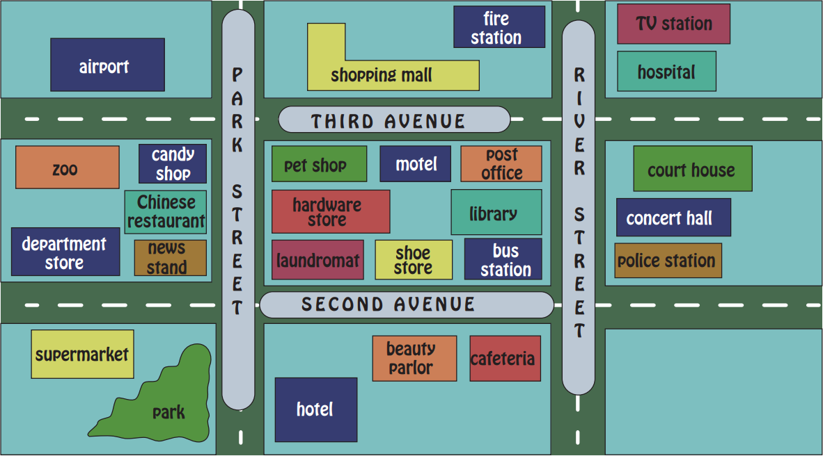
- I’m at the zoo. How do I get to the süpermarket?
First go out of the zoo. Turn right. Then, turn right from Park Street. Go ahead. Turn right after news stand. It is on the left.
- I am at the hospital and I want to go to the airport. Is it far?
It is not far. First get out of the hospital. Then, turn right. Go straight ahead. It is on your right after Park Street.
- I am at the hotel. Can you tell me the way to the concert hall, please?
First, get out of the hotel. Then, turn right. Turn left from River Street. It is the blue building on your right.

