Theme 2

Hobbies and Skills

*İngilizce’de bazı fiiller(love) ve belirteçli yapılar(good at) kendilerinden sonra gelen fiillerin –ing eki ile kullanılmasını gerektirir. Türkçe’de biz benzeri durumda dil bilgisi kuralı olarak eylemsi/fiilimsilerden söz edebiliriz. İngilizce’de de bu kast ettiğimiz eylemsiler kendilerinden önce kullanılan fiile ya da preposition’a göre gerund (V-ing) ya da Infinitive (to V1) olarak kullanılırlar. Bu ünitede hobilerimiz ve yeteneklerimizden bahsederken kullanacağımız yapılara dikkat ediniz. Görselleri inceleyiniz.

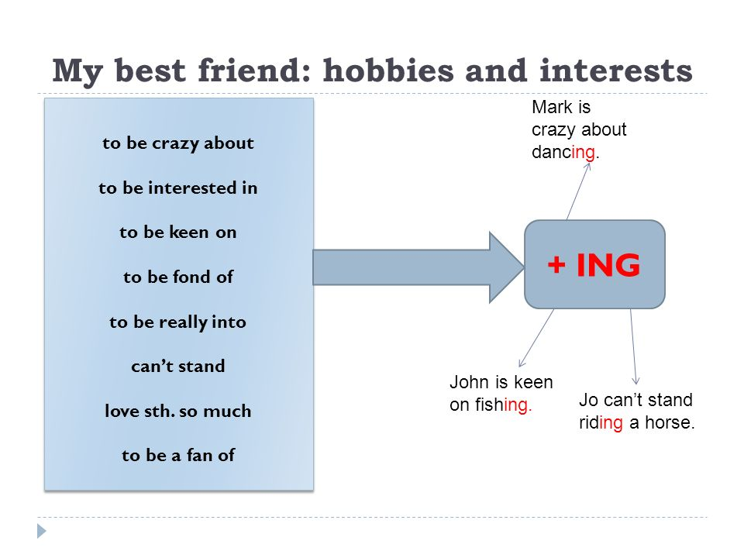

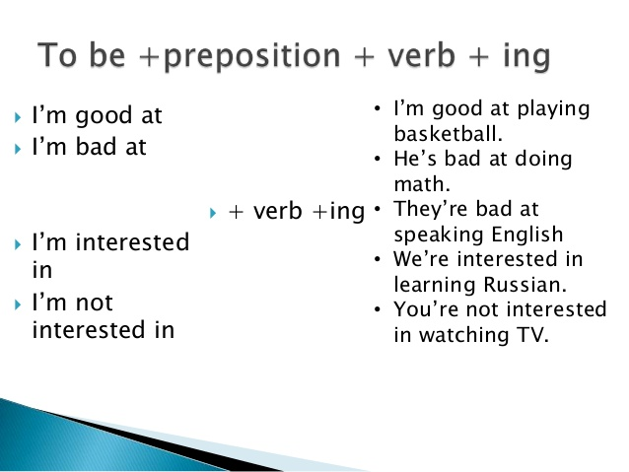 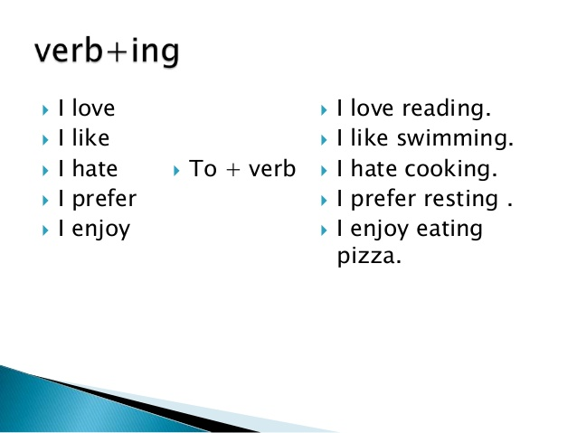

*Sevilenler,sevilmeyenler ve tercihlerimiz hobilerimizden bahsederken kullandığımız fiiler love, hate, like,prefer, enjoy, dislike, want ve would like fiilleridir. Present Simple Tense-Geniş Zaman yapısı kullanılarak genel olarak kişi hobileri ve tercihlerinden bahsedebilir.

Would like to V1

+

Want Noun

Love

Like

Hate + Ving

Dislike + Noun

Prefer

Enjoy

Kullanım özelliklerine dikkat ediniz,

**Positive Sentences**

|  |  |  |  |
| --- | --- | --- | --- |
| I | Like / Love | Noun or Ving | I like swimming. I hate ironing.  I dislike football. I dislike playing football. |
| You | Dislike | Noun or Ving | You enjoy eating fish.  You prefer swimming to walking. |
| We | Hate/enjoy | Noun or Ving | We like spending time together.  We hate mathematics. |
| They | prefer | Noun or Ving | Martin and Linda love going shopping.  They like chess. |

|  |  |  |  |
| --- | --- | --- | --- |
| She | Like**s** / love**s** | Noun or Ving | Marla loves hiking.  Linda hates extreme sports. |
| He | dislike**s** | Noun or Ving | Jack dislikes talkative people.  He hates going out at the weekends. |
| It | hates | Noun or Ving | My cat loves apples.  My dog enjoys playing with its tail. |

**Negative Sentences**

|  |  |  |  |
| --- | --- | --- | --- |
| I/you  we/they | don’t like,  don’t enjoy etc. | Noun or Ving | They don’t prefer spending time at home.  I don’t like eating spicy food.  We don’t enjoy skating.  You don’t hate sports. |
| He/She/IT | doesn’t like  doesn’t enjoy  doesn’t love | Noun or Ving | Sinem doesn’t like pottery.  Andy doesn’t prefer ice-skating.  The dog doesn’t like eating bones. |

**Ouestion Types**

**\***Do you like collecting stamps? Yes, I do. / No, I don’t.

*Does your father prefer tea? Yes, he does. / No, he doesn’t.

*What do you like doing in your free time? I like reading books.

*Where does your sister enjoy spending her time? She enjoys spending her time in her room.

***Sıfat ve belirteç (adjective+preposition) ile kullanılan yapıların cümle kurulumunu “to be” (am,is,are) ile yaparız.

I crazy about(delisi olmak)

You fond of(hayranı olmak)

We (to be) interested in (ilgili olmak) Noun

They (am,is,are) into(ilgili olmak)  Ving

He (‘m not, isn’t,aren’t) good at (iyi olmak)

She bad at (kötü olmak)

It keen on (hevesli olmak)

**Positive Sentences**

I am crazy about running in the mornings. Mandy is keen on puzzles.

My parents are really into rock music. Alex is interested in playing football.

**Negative Sentences**

Max isn’t fond of One Direction. I’m not very interested in watching movies.

They aren’t good at maths. She isn’t bad at cooking at all.

**Question Types**

Is your mother good at singing? Are you into going out tonight?

Yes, she is. / No, she isn’t. No, I’m not. / Yes, I am/ Yes, I’d love to.

What are you interested in? Which sports is he good at?

I am interested in learning languages. He is good at basketball and voleyball.

**Present and Past Abilities**

**Present abilities**

İçinde bulunduğumuz zamanda yeteneklerimizden konuşurken olumlu cümlelerde can+V1 olumsuzlarda can’t+V1 kullanırız. Soru sormak için öznenin başına can’i geçiririz. Can you_____?

**Past abilities**

Geçmiş yeteneklerimizden ise bahsederken could+V1 olumlu cümlelerde, olumsuzlarda ise couldn’t+V1 karşımıza çıkar. Soru sormak için öznenin başına Could’u geçiririz. Could you_____? Örnekleri inceleyiniz;

I can play the piano but I can’t play the guitar.

When I was a child, I couldn’t swim.

I can play the piano now but two months ago I couldn’t play it.

She couldn’t speak English fluently two weeks ago!

I could remember people’s names easily but I am an old person now.