Prefer - Would Rather

Aşağıdaki cümlelerde verilen boşlukları PREFER veya WOULD RATHER kalıplarına uygun olarak doldurunuz.
1I prefer (jog) to (cycle)
2I'd rather (swim) than (play) tennis.
3I'd prefer (watch) a movie rather than (watch) a cinema.
4I'd rather (travel) by plane than (travel) by bus.
5Jerry prefers (read) books to (listen) to music.
6I'd rather (eat) vegetables than (eat) meat.
7Sam prefers (phone) his friends to (chat)
8She'd prefer (go) on holiday rather than (stay) at home.
9 you prefer (read) or (write)?
10What would you prefer (do), ride a horse or a car?

Fill in the blanks using “Prefer” or “Would Rather”

1. Do you _____________________ watching extreme sports or documentaries?
2. They_____________________ making music to listening to it.
3. I ___________________play tennis than handball. It will keep me fit.
4. My sisters _______________________ cleaning the house than washing the dishes.
5. Diana ______________________ knit than sew.

Choose the best answer to fill the gap in each of the following:
1. I prefer coffee __________ tea.
a. to b. Than c. From

2. I don't fancy the theatre again. I'd rather __________ to the cinema.
a. to b. Go c. Going

3. Although I love relaxing on beaches, I think I prefer __________ in the mountains.
a. walk b. Walking

4. I'd rather speak to him in person __________ things over the phone.
a. than discuss b. to discussing c. to discuss

5. I prefer trains __________ cars.
a. from b. than c. To

6. I'm not a big fan of cars; I prefer __________ by train.
a. travelling b. Travel

7. If I had a choice I think I'd rather __________________ London.
a. live in Paris than in b. live in Paris to c. to live in Paris than

8. They'd rather have lunch inside, but I'd prefer ______________ outside in the garden.
a. eat b. eating c. to eat

Choose the correct option.

1-She ...................... eat a salad than a hamburger.
would rather prefer

2-They .................... dogs. They don't like cats.
would rather prefer

3-I ...................... stay home today.
would rather prefer

4-We ....................... watching basketball.
would rather prefer

5-Usually people ......................... warm weather.
would rather prefer

prefer

1. John ....................................voleyball to football.
prefer
prefers
to prefer
prefering

2. "Which one is wrong?"
Jane and Judy don't prefer talking to sleeping.
Jane and Judy prefer talking to sleeping.
Do Jane and Judy prefer talking to sleeping?
Does Jane and Judy prefer talking to sleeping?

3. A: "Which one does he prefer, watching TV or playing computer games?"
B: ..................................................
He prefers watching TV.
Yes, he does.
No, she doesn't. She likes voleyball.
She wants to go out with her friends.

4. I prefer travelling by car ............ bus.
by
on
at
to

5. She prefers ..................................

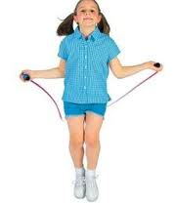
pizza to spaghetti
playing alone
sitting up here
watching TV

6. Tom prefers ..............................

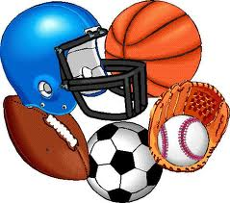
horror films to western films
playing chess to playing football
hamburgers to spaghetti
sports programmes to chat shows

7. I ...................... watching TV to ......................to the radio.
prefer / listen
prefer / listening
prefer / listens
prefers / listening

8. Lisa prefers ........................ to swimmimng.

sunbathe
to sunbathe
sunbathes
sunbathing

9. He prefers ...................... a taxi to a bus.
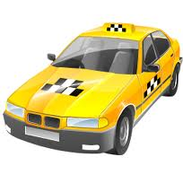
taking
take
takes
to take

10. They prefer ........................................ .
cake making to biscuit
biscuit to make a cake
making a cake to biscuit
make biscuit to cake

